Introduction: Have you ever thought about how much information it takes to make a weather forecast? In order to make accurate weather forecasts, meteorologists must gather tremendous quantities of data about local weather conditions from across the country. Data are collected from satellites and from over 600 weather stations throughout the country. These data are pooled together to make detailed weather maps. Meteorologists use weather maps to record changing weather patterns and to show the movement of weather systems. In this map exercise, you will study weather maps showing conditions across the United States. Based on these maps, you will be able to see for yourself the movement of weather systems and even make rough forecasts about how weather conditions will change over time. Get ready for the challenge!
Directions:
-Use the weather map & city map as a reference for city names.
-use your Weather Map symbols resource page to help you answer the activity questions.
-Answer ALL questions in your INB and create your own weather map.
-When you are finished, please put all resource papers in their correct piles on the front lab table.

- What two cities contain 1012 millibars of atmospheric pressure?
- Describe the cloud cover, wind speed & wind direction of Colorado Springs, Colorado.
- Which states are experiencing a warm front?
- Describe the weather in Sante Fe, New Mexico.
- Identify the city or “closest” city with the highest wind speed.
- Describe the cloud cover, wind speed, wind direction & storm systems that are occurring in the Gulf of Mexico.
- What areas in the U.S. are experiencing large amounts of rain and cloud cover?
- What is the source of this type of weather? (refer to question 6.)
- What type of temperature is associated with High pressure systems? (Use the weather map as a reference.)
- Describe the temperature and weather in Baltimore, Maryland.
- Is the region of “Tornado Alley” going to experience a tornado with the current weather? EXPLAIN your answer.
(Use page 589 in the red textbook as a resource.)

- On the blank U.S map that you received from Mrs. Obermeyer create a weather map with the following weather points
  - Seattle- 100% cloud coverage, 6 mph wind S, heavy rain
  - Memphis- 81º, 40 % cloud coverage, 13 mph wind SE
  - Denver- 48º, 30 % cloud coverage, 10 mph wind N
  - Omaha- 50% cloud coverage, 9 mph wind NW
  - New York- hail, 58º, 80% cloud coverage, 7 mph wind W
  - Phoenix, Taos, and Sedona have 1012 millibars of atmospheric pressure
  - Las Vegas, Aspen, Wichita, Dallas and El Paso have 1000 millibars of atmospheric pressure
  - Philadelphia, Cincinnati, Branson region is experiencing a low pressure cold front
  - Insert weather symbols associated with the cold front around the region in the letter H.
  - Draw a large precipitation area the upper Florida area.
  - Along the East coast by Atlanta. Insert a hurricane in the Atlantic Ocean.
  - Place 980, 990, 1000, and 1010 isobars surrounding the hurricane.
  - Insert the current weather for Meridian, Idaho

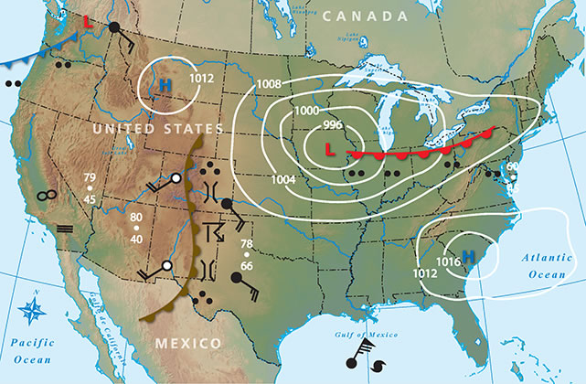
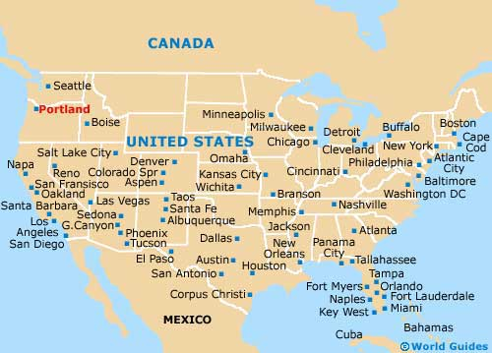
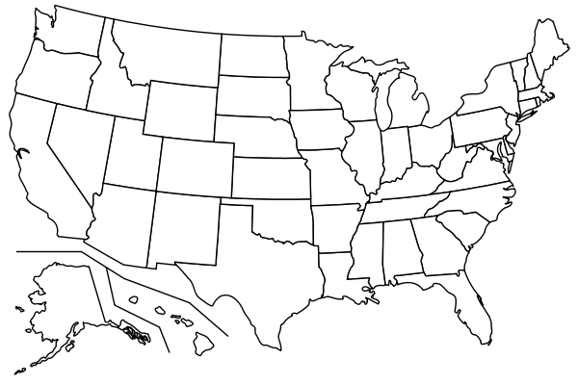

Weather Map Symbols Resource Page
