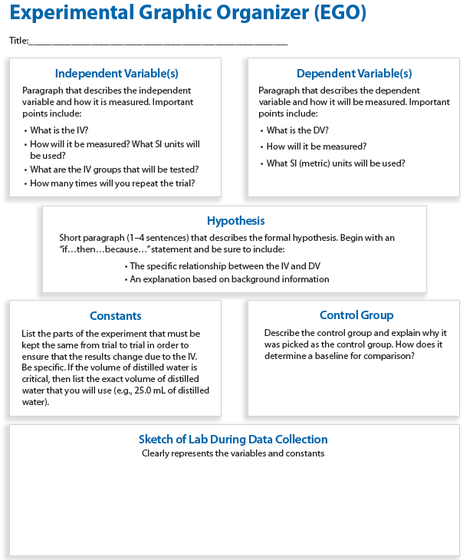**Experimental Design Lab – Magazine Ad Experiment**

Experiment Procedure

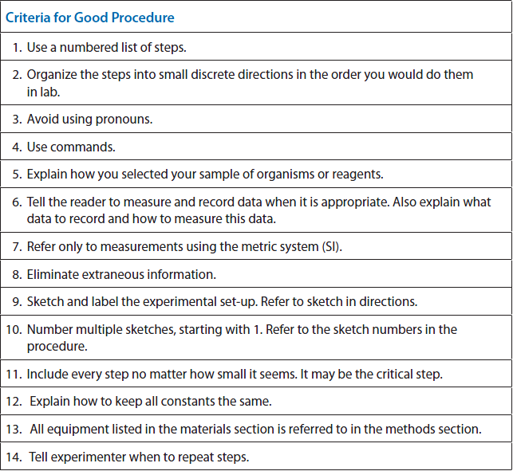

**Experiment Set-up sketch**

-Includes: Labels, color, constants, IV, DV, control group

-What would your experiment look like?

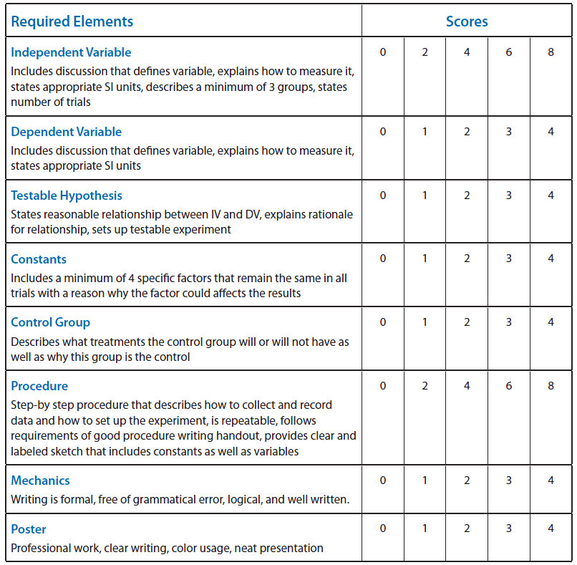**Grading Rubric:**