Managing Mosquitoes

Malaria is a serious infectious disease in the tropics that can cause high rates of mortality, especially among children. During the early 1950’s, malaria was a serious problem to the Dayak people of Borneo. In an effort to stop this epidemic, the World Health Organization (WHO) decided to rid Borneo of malaria by killing the mosquitoes that spread this disease. WHO used a potent insecticide called DDT. The mosquito population was soon wiped out, and the incidence of malaria greatly reduced. But the consequences of this treatment were much more far reaching than anyone could have predicted.
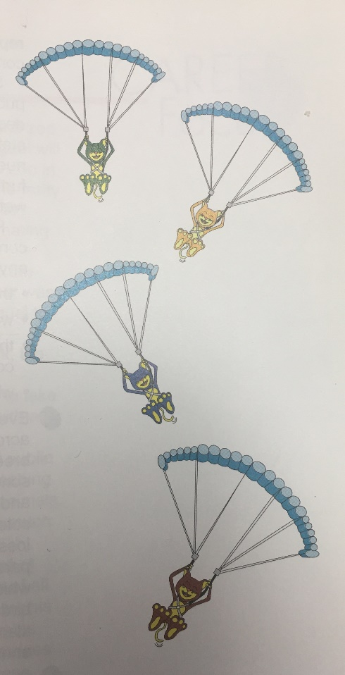
Not too long after the spraying of DDT, the thatched roofs on the houses began to collapse. More distressfully, outbreaks of two new infectious diseases, sylvatic plague and typhus, began to appear in the villages. Was there a relationship between getting rid of the mosquitoes and the new problems in the village? The answer lay in food webs! DDT is an insecticide, so it affected not only mosquitoes but other kinds of insects in the sprayed area, including roaches. The roaches accumulated the DDT in their bodies, even though it did not kill them outright. Roaches are a favorite food of a small lizard called a gecko. When the geckos ate the DDT-laced roaches, the insecticide accumulated in their bodies. It did not kill them either. But it made these normally lightning-fast lizards slow down and, thus, become easier prey to the village cats. When the cats ate the lizards, they did die from DDT poisoning. With no cats to control them, rats flourished, bringing with them the diseases that they carried, plague and typhus.
But what caused the roofs to collapse? In addition to roaches, geckoes also enjoy dining on a species of thatch-eating caterpillars, thus keeping their numbers in check. Without the lizards to eat them, the caterpillars multiplied out of control. This resulted in large numbers feasting on the thatch roofing material of the village houses.
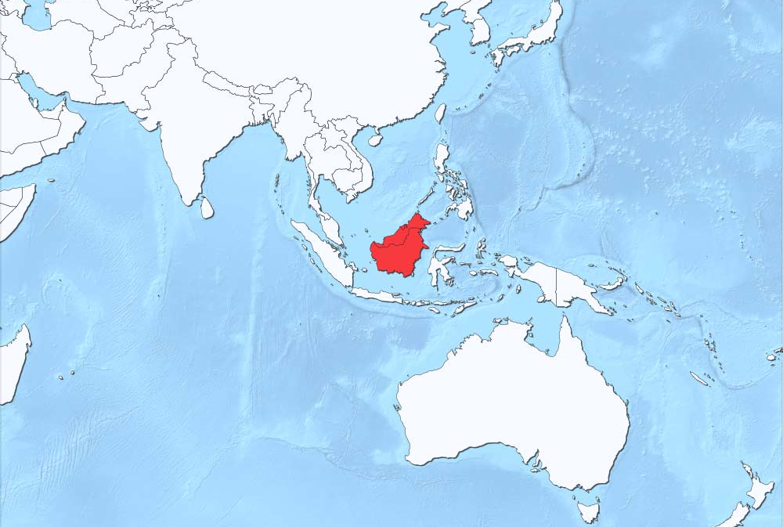
Realizing the problems that its program has created, WHO parachuted hundreds of cats into Borneo in an attempt to repair the damage.

