Molecules of Life
Class Copy
Student Study and Analysis Sheet
Introduction
Carbohydrates, lipids, and proteins are three of the major groups of organic chemicals which make up cells in organisms. They are responsible for everything from storage of energy to support structure within a cell system. The chemical elements carbon, hydrogen, and oxygen make up each of these molecules. How these elements are arranged dictates the type of molecule that’s formed.

Carbohydrates have a specific numerical relationship between their elements. The ratio of one carbon to two hydrogens to one oxygen atom is consistent throughout the smallest to largest molecules. The smallest unit of the carbohydrate family is called a monosaccharide (also known as “simple sugar”). Though occasionally found in a chain form, the monosaccharide normally exists as a ring consisting of 5 carbon atoms, and one oxygen, surrounded with oxygen and hydrogen atoms. Glucose is a common monosaccharide with a molecular formula of C6H12O6, showing the familiar empirical formula ratio of one carbon to two hydrogens to one oxygen.

When two monosaccharides combine they form a disaccharide. Common disaccharides include lactose (milk sugar) and sucrose (cane sugar). Additional combining reactions to a disaccharide create a polysaccharide. In nature, thousands of simple sugars bond to form polysaccharides such as starch and cellulose (structural component of plants). A carbohydrate’s primary function, providing energy for an organism, occurs when a monosaccharides carbon-hydrogen bond is broken. Each time a carbon-hydrogen bond is broken, energy is released and used for various purpose in a cell. Since a typical polysaccharide, like starch, contains thousands of these bonds, the energy that a carbohydrate gives off far exceeds most organic compounds.

Objective
Models will be used to visualize various carbohydrates. Emphasis will be placed on how these molecules are joined and broken apart.
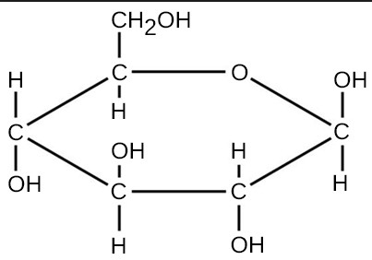
Materials needed per group:
10 black, carbon atoms
28 yellow, hydrogen atoms
6 red, oxygen atoms
2 blue, nitrogen atoms (not used in this activity)
Short, white tubes-single chemical bonds
Long, white tubes- double chemical bonds (not used in this activity)

Procedure
Part 1- Construct a Monosaccharide (simple sugar)
- Obtain five carbon atoms, one oxygen atom, and six single bonding tubes from your bag. Join the five carbons and one oxygen in a chain, with one bond between each atom. Now, make your chain of atoms into a ring without bending any of the bonding tubes. Note that all six atoms are not on the same plane, which allows the ring to bend upwards and/or downwards. This structure if the most stable arrangement for the atoms.
- Place the ring on the table in front of you with the lone oxygen atom at the “twelve o’clock” position. Add the sixth carbon to the carbon in the ring counter-clockwise of the lone oxygen. Fill the remaining open bonding sites of each carbon atom with one hydrogen and an oxygen-hydrogen atom pair. Use the picture above as a reference. Hint: you should have NO open bonding sites. The simple sugar you made is called glucose!!
- Build a second glucose molecule in preparation of the next step.
*Answer analysis questions

Part 2- Combining Monosaccharides
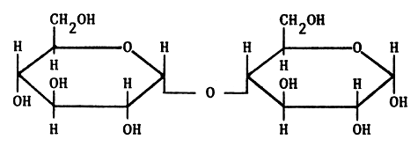
- Place the two glucose models in front side by side so the ring oxygens are at the “twelve o’clock” position. See the diagram below to position the two glucose molecules. Can you guess where and how these two monosaccharides will join?
- On the left glucose molecule, locate the first carbon found clockwise from the oxygen in the ring. This carbon has a hydrogen and an oxygen-hydrogen section branching off of it. Now the locate the oxygen-hydrogen section bonded off this carbon. Remove the hydrogen (with the bonding tube) from the oxygen-hydrogen section of the glucose.
- On the right glucose molecule, locate the first carbon counter-clockwise from the oxygen in the ring. This carbon has another carbon branching off of it. Now locate the oxygen-hydrogen section of the carbon counter-clockwise of the lone oxygen. Remove this oxygen-hydrogen combination (without the bonding tube) from this glucose.
- Join the two monosaccharides to create a disaccharide. This disaccharide you have made is called maltose.
- Now bond the two removed pieces together.
*Answer analysis questions

Part 3- Making a Polysaccharide
- Work with the pair next to you. Use the Dehydration synthesis process to join together your two maltose molecules to form a polysaccharide. Two common groups of polysaccharides are starch and cellulose. Each contains hundreds, if not thousands, of glucose linked together.
*Answer analysis question

Part 4- Breaking down a Polysaccharide
- Use the water molecules that were formed during Dehydration synthesis. Add a hydrogen or hydrogen-oxygen pair back to each individual ring to form four glucose molecules.
- Each lab pair should have the same two glucose molecules that were built during Part 1.
*Answer the remaining analysis questions.

Break down ALL components and return pieces to the bag.

